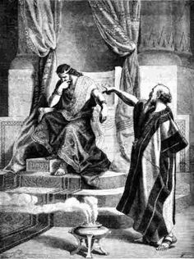
Jesus in Psalm 51: Ancient Meditations on the Hope of Forgiveness
Intro: The Inner and the Outer Monologue…
I. Background and Context of Psalm 51
- “a psalm of David… when the prophet Nathan came to him…” (2 Sam 11:1-12:25)
- Psalm includes: introduction, confession, plea, vow, concluding prayer for Israel
- One of 7 penitential psalms of the Lenten season (Ash Wednesday reading)
- Unique in its absence of an enemy… a straight up confession and plea for forgiveness
II. The Beauty and the Big Questions of Psalm 51
1. To what degree is seeking forgiveness ritualistic to David and to what degree is it a spiritual pursuit? Leviticus 1-7 vs. Psalm 51:10-12
2. Does David believe that God wants sacrifice and penance from sinners, or a broken spirit? Tension point! Broken spirit: Psalm 51:16-17 / Sacrifice: Psalm 51:18-19
3. What are the messianic tones of David pursuing a purity granted by God, independent of behavior? Psalm 51:7 and Exodus 12:22, Heb 9:19-28
III. The Ultimate Answers of Psalm 51
a. What is the basis of our forgiveness?
- David appeals for forgiveness based on: the essential character of God (Psalm 51:1-2)
- We appeal for forgiveness based on: the work of Jesus Christ
(Psalm 51:2, Matt 23:25-26, Hebrews 9:14)
b. How should forgiveness change us? (Psalm 51:15-17)
“The psalmist has lived through the dark night of the soul and emerged on the other side, ready to teach others the ways of God” Nancy DeClaisse Walford
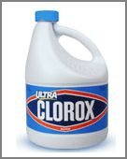
Small Group and Individual Study Questions: Psalm 51

1. What is the worst stain that you can remember creating or discovering?
Did you eventually remove it or discard it? Share the story..
2. Go through Psalm 51, what does David teach us about the importance and the methods of confession?
3. Since we are given the details of the situation that surrounded the writing of this psalm (in 2 Samuel 11:1-2:25) what is so surprising about David’s comments in Psalm 51:4? Doesn’t it seem like David has also sinned against Bathsheba and Uriah? What is David claiming is ultimately true of all sin?
4. In Psalm 51:17 David says that God wants sinners to have “a broken spirit and a contrite heart.”
- What evidence do we have in Psalm 51 that David had these?
- What are some ways that these things show in a contemporary person’s life?
5. Many powerful worship songs borrow images and ideas from Psalm 51:7-12. List the things that David is asking God for..
What are your personal challenges of maintaining these things over the years?
How does David seek to have them restored? Is this still available to us?
6. What are the things that David appeals to from God as a basis for his forgiveness (hint: Psalm 51:1-2)?
What should a New Testament Christian appeal to as the basis for our forgiveness (Hebrews 9:14)
7. What does David promise to do once he is forgiven in Psalm 51:13-15?
Discuss how are you living up to and falling short of this example.
Pray for each other to grow in: purity of heart, knowledge and delight of God’s presence, and the joy of your salvation! (Psalm 51:10-12)

